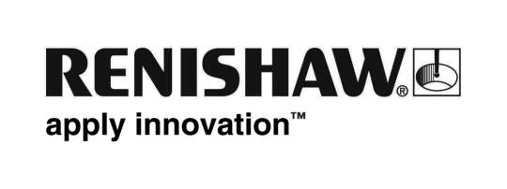
February 2018 Enquiries: Chris Pockett, Head of Communications (+44 1453 524133)

Renishaw showcases intelligent machining processes at MACH 2018

At MACH 2018, global engineering technologies company, Renishaw, is exhibiting its precision measurement and additive manufacturing solutions. From the 9th-13th April, the company will demonstrate its offering as a manufacturing partner, showcasing how its measurement technologies can be integrated into a manufacturing process to achieve intelligent machining. The company will exhibit new products alongside its existing range.

The company will exhibit its extensive metrology products on Stand H19-430. Renishaw will also exhibit on a separate, dedicated additive manufacturing stand on stand H20-150.

One key highlight on the main stand, is a high-productivity machining cell concept, boasting integrated process control. By monitoring key process inputs, analysing data and continuous improvement, manufacturers can increase accuracy and productivity.

Other highlights include the company’s latest scanning system for CNC machine tools, intelligent process control software for the Equator™ gauge and apps to simplify machine tool probing. The company will also present a non-contact tool setter for machining centres, a multi-probe optical interface system, a new surface finish probe for use on the REVO® 5-axis measurement system on co-ordinate measuring machines (CMMs) and enhanced software for Renishaw's XM-60 multi-axis calibration system.

“Industry 4.0 depends on connected systems, able to communicate, interpret and respond to information in real time,” explained Paul Maxted, Director of Industrial Metrology Applications at Renishaw. “Measurement data is essential to gather information to be used in intelligent decision making to prevent process variation.

“Real-time status updates from all systems are currently limited to a very small percentage of manufacturers,” continued Maxted. “Renishaw is the ideal partner for manufacturers moving towards more intelligent production. By working with Renishaw, manufacturers can streamline processes and improve productivity and efficiency.”

From its dedicated additive manufacturing stand in Hall 20, Renishaw will exhibit its software and systems for the production of metal parts. This includes the RenAM 500M, alongside demonstrations of QuantAM, the company’s build preparation software. At the show, Renishaw will highlight the productivity benefits of its four-laser system, which offers increased productivity in the most commonly used machine platform size.

“Renishaw is pioneering productivity in additive manufacturing,” explained Marc Saunders, Director of Global Solutions Centres at Renishaw. “By improving productivity and reducing cost per part, Renishaw is moving additive manufacturing to the mainstream. MACH is the ideal place to showcase the latest developments in additive and how the technology can be successfully integrated into manufacturing operations.”

MACH is the UK’s leading trade show for the manufacturing technologies industry. Chris Pockett, Head of Communications at Renishaw, is Chair of the MTA’s Exhibition Committee which has oversight of the organisation of MACH exhibitions.

For more information on Renishaw visit www.renishaw.com.

Ends 437 words
Notes to editors
UK-based Renishaw is a world leading engineering technologies company, supplying products used for applications as diverse as jet engine and wind turbine manufacture, through to dentistry and brain surgery. It has over 4,000 employees located in the 35 countries where it has wholly owned subsidiary operations.

For the year ended June 2017 Renishaw recorded sales of £536.8 million of which 95% was due to exports. The company’s largest markets are China, the USA, Japan and Germany.

Throughout its history Renishaw has made a significant commitment to research and development, with historically between 14 and 18% of annual sales invested in R&D and engineering. The majority of this R&D and manufacturing of the company’s products is carried out in the UK.

The Company’s success has been recognised with numerous international awards, including eighteen Queen’s Awards recognising achievements in technology, export and innovation.

Further information at www.renishaw.com

